Life Skills Level 2 Lessons
DESE and SPS suggest for students to engage in meaningful and productive learning for approximately half the length of a regular school day. Please determine what is best for your family or child and feel free to choose from the review activities/ lessons provided for each week. Please reach out to us if you have questions or concerns.
Good Morning/ Calendar
Find a calendar. What month is it? What’s the date & day of the week. What was yesterday? What will tomorrow be?
Songs: Greg & Steve- Good Morning: Good Morning Months of the Year: Months Letters: Chicka Boom Boom
What’s the weather like today? What should you wear to “dress for the weather”?

Week of May 18 | Week of May 25
Question of the week: What is your favorite part of the zoom meetings? Why?  (Send response to teacher in DoJo or via email) | Question of the week: Did you and your family do anything to celebrate Memorial Day? What did you do?  (Send response to teacher in DoJo or via email)
OTHER ACTIVITY IDEAS:

Tally Marks-Use tally marks on a piece of paper to track the weather for a few days, a few weeks, or even until we get out of school! Will we have more days that are sunny, cloudy, rainy, or even snowy? Make a prediction and then keep track to find out!

Thank You Hospital Workers Mr. Nomar's Video

ELA Work
IReady (ELA) Independent Level Practice- approximately 45 minutes per week - or-
Imagine Learning for ELL students
Both sites can be found on the Student Application Page

Reading – Read books to your child for approximately 20 minutes per day. (You can read books from home or books on www.getepic.com or Scholastic At Home.
Video Directions Below:
How to Get on Epic

Unique Curriculum- students can go to the Unique Learning Curriculum lessons on the Unique Website
Video Directions Below:
Logging In with Username + Password

Complete the lessons that are listed and pictured below for each week. (The activity numbers you see below may not match these pictures, and that’s ok! Match the image and the title)
Week of May 18 | Week of May 25
Unique lessons: login to Unique and click the icon that looks like this (may be blue or orange):  Reading:  Comprehension:  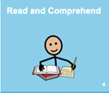  Vocabulary:  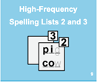  Letter work:  Mrs. B's Letter Work Video  IReady Reading: 45 minutes per week | Unique lessons: login to Unique and click the icon that looks like this (may be blue or orange):  Reading with comprehension questions:  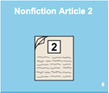  Vocabulary:  Writing Time (once in writing time, pick ONE of the two pages below):  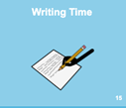  THEN...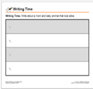 OR 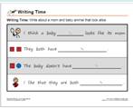  IReady Reading: 45 minutes per week
OTHER ACTIVITY IDEAS:

Letter/Word Search- Look for letters and words in everyday things around the house. What letters/words do you see on food packages? On clothing? In newspapers or magazines? Can you find all the letters of your name? All the words on our spelling lists?
Look at or read a book-Find a book with pictures and make up a story that goes along with the pictures in the book.

Create You Own Sentences- Create your own sentences with this week’s spelling list

Movement
Children will engage in movement activities.

Week of May 18 | Week of May 25
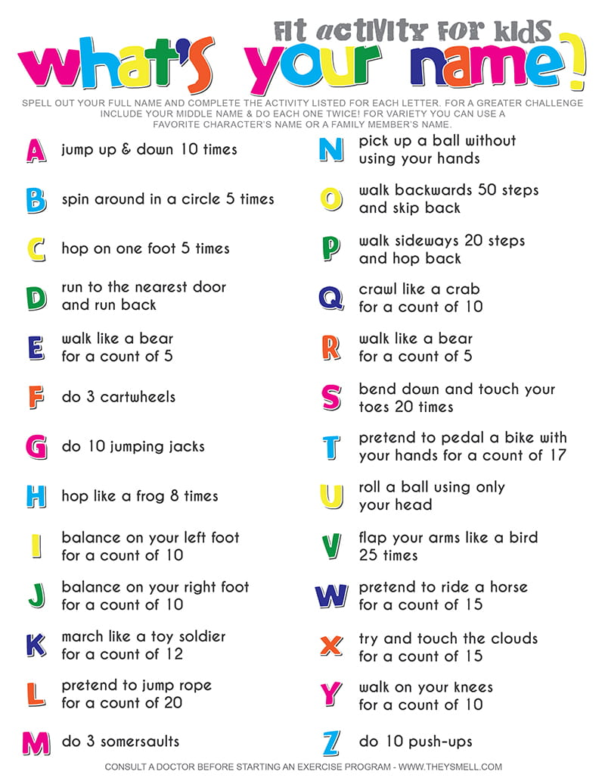 | Indoor: Jack Hartmann Springtime  Brain Break  GoNoodle.com- check out some of your favorite Go Noodle videos and “Get Moving!”  Outdoor:  Work on your locomotor skills – go outside and practice walking, running, galloping, skipping, jumping and hopping
OTHER ACTIVITY IDEAS:

Nature walk- Walk around neighborhood with an adult and look for three signs of Spring. Draw and label each sign of Spring that you find.
Exercise- go outside or inside (where there is enough space) and do 10 jumping jacks, 10 sit ups, run (in place if inside) for 2-3 minutes, play hopscotch if outside.
Outside Activities- use chalk to draw pictures on the driveway, play hopscotch, try to find one thing for every color of the rainbow Red, Yellow, Orange, Green, Blue and Purple.

Math Work
IReady (Math) Independent Level Practice- approximately 45 minutes per week
Student Application Page

Unique Curriculum- students can go to the Unique Learning Curriculum lessons on (website here).
Complete the lessons that are listed and pictured below for each week.

Week of May 18 | Week of May 25
Unique lessons: login to Unique and click the icon that looks like this (may be blue or orange):  Survey and Chart:  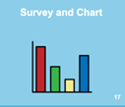  iReady Math: 45 minutes per week | Unique lessons: login to Unique and click the icon that looks like this (may be blue or orange):  Geometry:  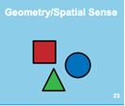 (Room 222)  Fractions:  (Room 223)  iReady Math: 45 minutes per week
OTHER ACTIVITY IDEAS:

Sorting- Count, sort, add, or subtract objects in your house. (silverware, clothing, toys, Legos, cookies, goldfish, etc.) Do you have more, less, or the same number of forks and spoons at your house?

Cook or Bake- help an adult measure all the ingredients and follow the directions to cook or bake something to eat.

Money- Grocery Store Bill- Estimate how much each item on the grocery list will cost. Add up the total amount of money you will need.
- Counting Change- look around your house for change. Sort the change, count the change, add up all the change
and see how much money you have!

Telling Time- Practice telling time using this fun, interactive clock! https://www.roomrecess.com/Tools/InteractiveClock/play.html

Submitting Work- All work done on Unique, Epic and iReady will be automatically submitted! Mrs. Shermer and Ms. Biscoe will be able to track your progress. We can’t wait to see all your hard work!
We’d love you to send pictures of you learning at home to share on our

